
Loyalty Tri-V Umph
Cooperation July 2008
Friendship

President-J. Clingerman-248-788-1378 Sec.-D. Angelosanto-734-422-3501
V. President-M.Trachsel-586-484-0836 Treas.-J. Steinhauer-734-459-4471

President’s Message

June was a big month for two of our members. We officially made Steve Trachsel a Tri-V member on June 6th. Like most of the Trachsels, he has been around Tri-V for a long time, but it is great to have him a member now. I got to know Steve through our Fantasy Football and bowling league. He has a great sense of humor and enjoys many sports. Both of these traits will serve him well as a member. Mike Lardin made the plunge into life as a married man. Congratulations and good luck to Mike and Bev Pritchard.

July will bring us the Tri-V picnic. With our younger member's wives continuing to get pregnant at an alarming rate, the children's games will continue to be a large part of the picnic. As one of the old guys whose children are grown up, I enjoy watching the children having a good time, but also am happy that someone else is taking them home.

John C

The Wedding

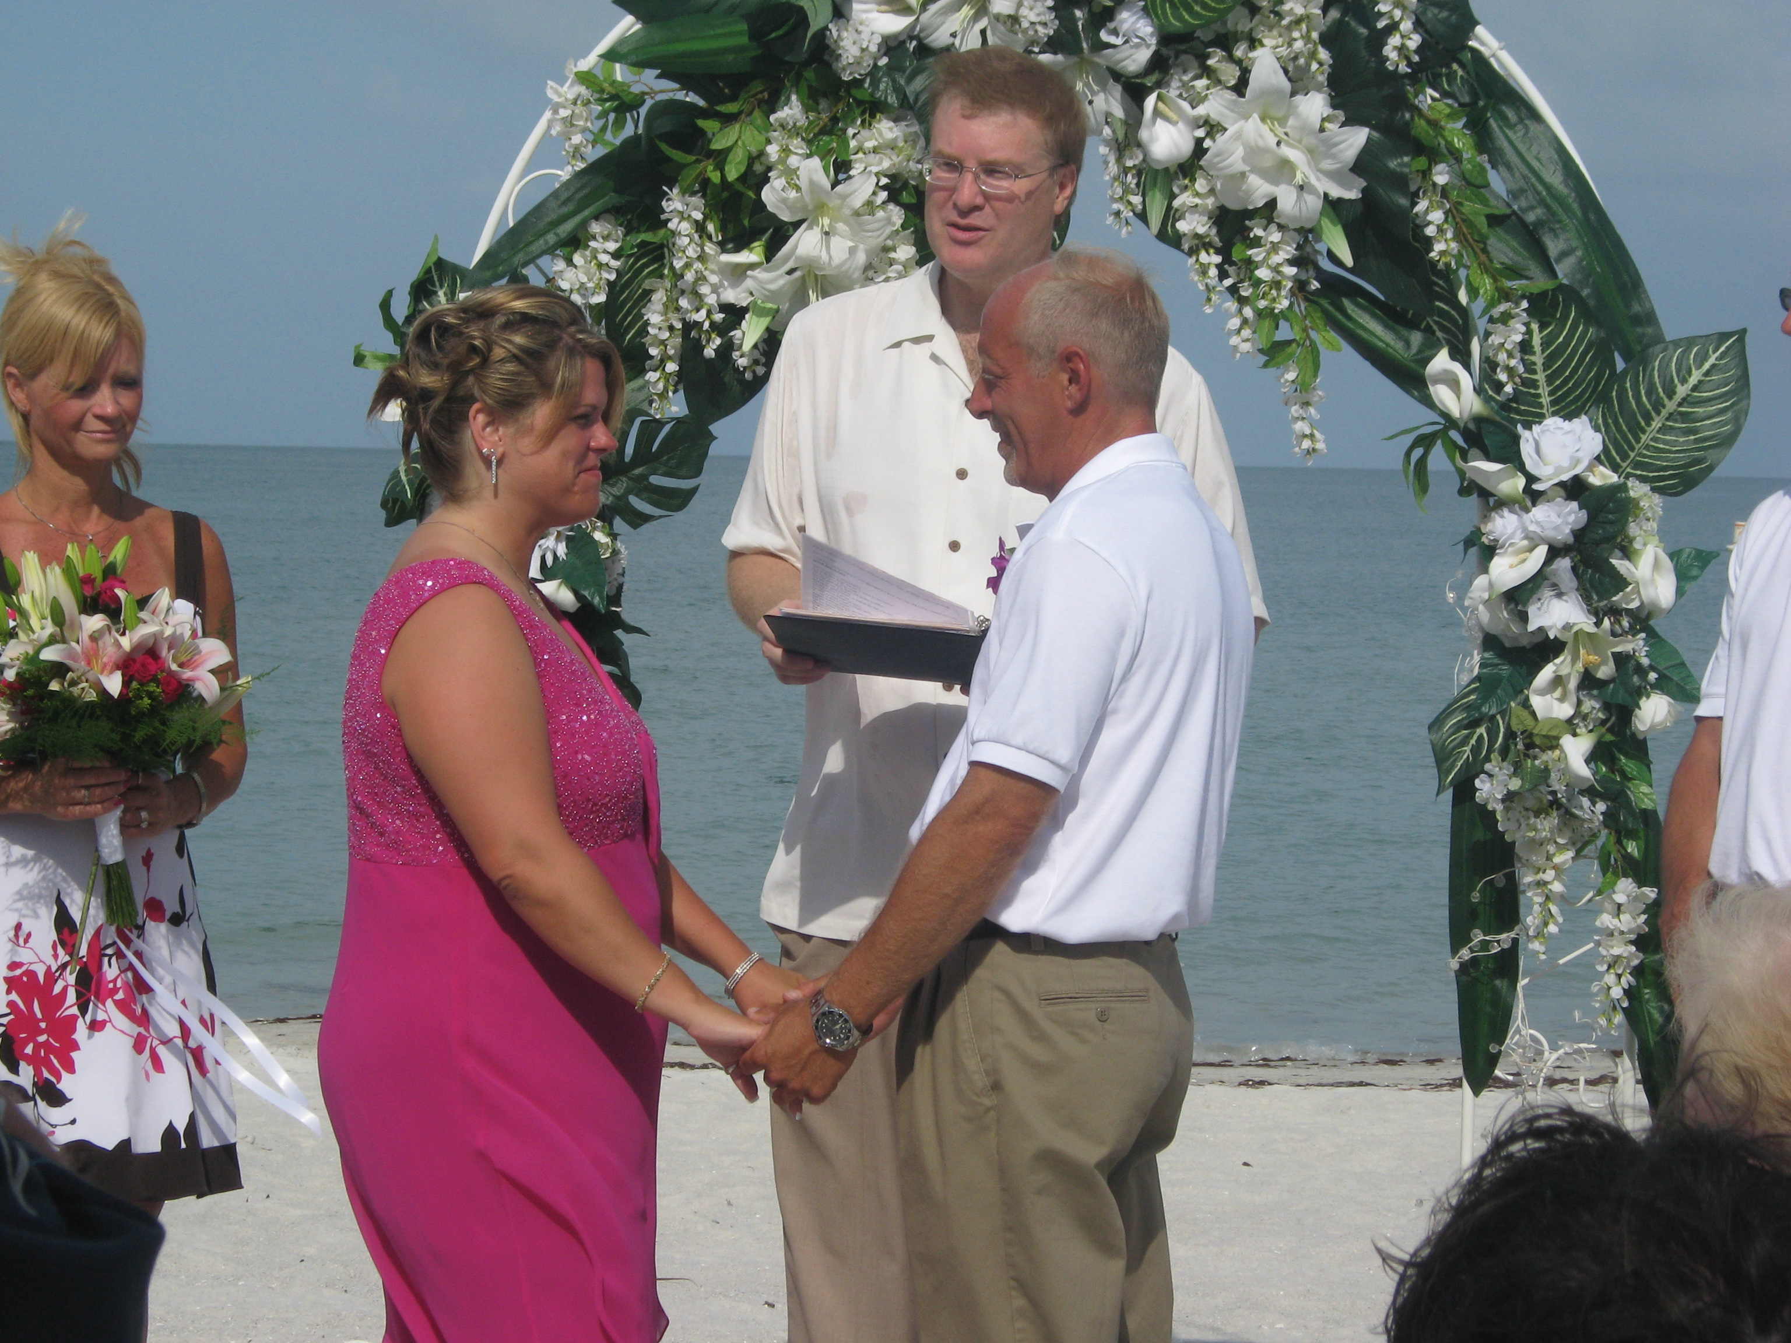
CAN YOU BELIEVE IT?? Mike stated that I had to travel to Florida to see it to believe it. On June 21, long standing member Mike Lardin, (son of John & Judy Lardin) married Bev Pritchard on the beach in Lowdermilk Park, Naples. Best Men were Matt VanHollebeke and Mark Toth. Maids of Honor were Karen Mitchell and Deanna Delacher. The ceremony also included a part where her sons, Nicholas and Benjamin were also married into the family. The weather was sunny and hot. After the wedding, a brunch was served at the home of her parents, Bill & Nancy DeJohn. In the evening, a dinner was enjoyed by all at the Silver Spoon Café. Several members of Tri-V made the trip to attend the wedding. Congratulations and many years of wedded bliss to Mike & Bev!!!!

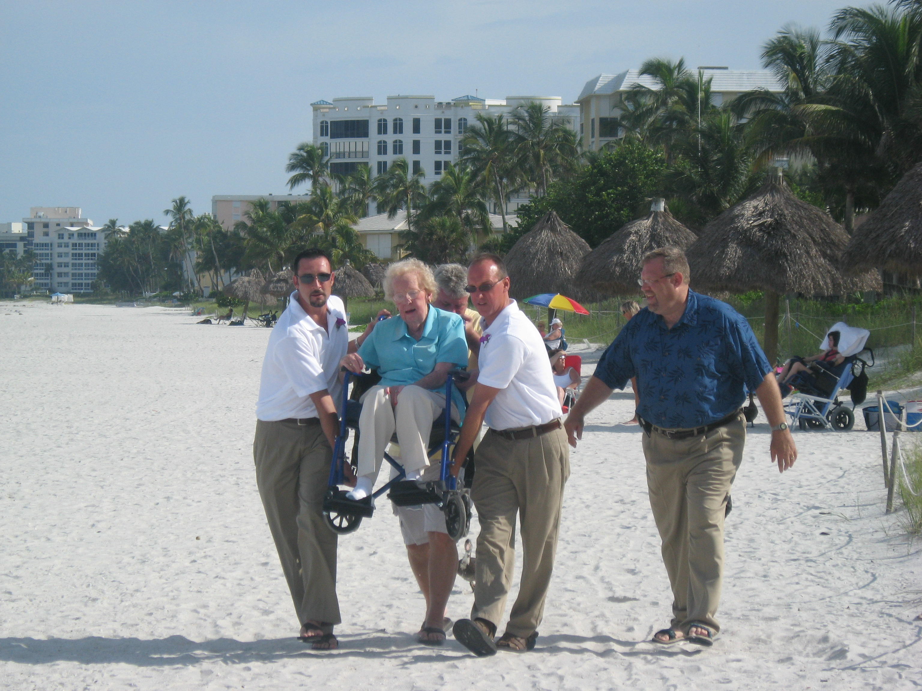

Peg Wendt gets a royal ride to the beach to attend the wedding of Mike & Bev.

Wives Club Meeting

July swim Blondie Forsyth's, Wed. July 16
Arrive anytime after 3:00 pm
Dinner served 5:00 pm
ALL women of Tri-V are invited.
Bring a salad to pass, your drinks and place settings.
If you will be coming from work and a salad is inconvenient please ask Blondie what else you can bring.
Wed. Aug. 20 girl's club at Marian Anderson's home.

Book Club

Book Club will meet at Ellie Connolly's on August 4 to discuss "Dangerous Fortune" by Ken Follett. September 8 we will meet at Irene Bliudzius's to discuss "The Outlander" by Diane Gabaldon. Oct. 6 we will be discussing "Blackbird (A childhood lost) by Jennifer Lauck location TBD. If you've read a book that you think would be a good book for discussion, please let one of the regular members know. The regular members of book club are Victoria Angelosanto, Karlyn Gies, Sherry Kuhr, Ellie Connolly, Jacqui Schaefer, Peg Hoffman, Judy Lardin, Irene Bliudzius, and Renee DeOrtenzio. Others who have attended are Dolores McMillan, Donna Clingerman, and Glenda (Ellie's neighbor).

Final Golf Outing

Saturday, August 16th through Monday, August 18th
Kendallville, Bestwestern

The Committee has arranged a great weekend for final golf. We will start on Saturday, August 16th at the same course as last year - Glendarin. This is a very nice course, free driving range to warm up (assuming your breakfast is served in a timely fashion so everyone shows up on time, hint, hint). Dinner (2-3 entree buffet) following at Carusos (Glendarin). Sunday golf will be at Bridgewater with dinner following - Prime rib or an alternate. Monday’s golf is at Cobblestone. There will be the breakfast bar available at the Bestwestern and lunches are on your own. The Committee will have snack stuff for the Bixler Room (hospitality suite). We will also provide water bottles for golf on Sunday and Monday. The Tee times are as follows -

Day 1: Sat, Aug. 16 Glendarin Hills 12:30pm (18 holes). Appetizers, dinner following at Carusos (Glendarin restaurant)
Day 2: Sun, Aug 17 Bridgewater East 11:10am (18 holes). Appetizers, dinner following at Bridgewater
Day 3: Mon, Aug 18 Cobblestone 9am (18 holes)

Total cost per person: $343.59 includes 2 nights lodging, tee times listed above, cart fees, taxes, Bixler Room, breakfast bar, meals (2 dinners), and prize money.

Payment info - $100.00 is due no later than July 1st. Please give your deposit to Dick Barnes. Billing for the room, golf, cart, taxes will be billed to you through Bestwestern when you check out on Sunday morning for the amount of $243.59.

It is extremely important to be on time Saturday. It only takes one missing person from the first few foursomes to completely wipe out the format. We are asking everyone to be there no later than 11:30am. They have a free driving range. No denim is allowed at Glendarin and all shirts must be collared. This is a great, beautiful, prestigious and difficult course. Playing your own ball is not the format we want for this course... so again.... be on time.

Looking forward for a Great Weekend, Your Final Golf Committee, Brett, Dick, George, John

Couples Golf

The following dates have been selected to avoid holidays and scheduled Tri-V events. The plans are to have host sign up for the scheduled events.... If nobody volunteers... Then I will Schedule a golf course the last week and send e-mails to everybody and we will party at the golf course following the golfing.....Dates are as follows: July 20, August 3, August 24, September 7 or 14 will be the final weekend... Volunteers are needed for this also...Please advise me of when you would like to host.....First come First serve...Geo Hoffman

Steak Roast

The Steak Roast will be held at Gunner Mettala Park in Wixom at the main pavilion shelter on August 9. The park is located on Maple Road (15 Mile Road) between Beck Road and Wixom Road (closer to Beck Road).

The committee will be there at 2:00pm and dinner will be at 5:00pm so come early and enjoy the great outdoors. There are tennis courts, baseball fields and walking paths available if interested in some side activities. Also you are welcome to bring any other games you would like to play.

Remember to bring your chairs, place settings and beverages. The main menu will
Be NY strip steak, corn on the cob, salad, dessert and coffee.

See you there! Chairman, Cal Cashman

Tri-V Picnic

The Tri-V Picnic will be on Sunday July 27th, 2008 at Gunnar Mettalla Park in Wixom. Note the date change from the last article. We will be eating at 1:00pm with games to follow. Hope for good weather and a great Tri-V turnout. We will be needing meats, casseroles, salads, and desserts. Please let John Mackson know if you will be attending by July 10th and let him know what type of dish you will be bringing so that we can be sure to have a good balance of dishes to pass. Look forward to seeing you there.

Wives Weekend Outing

All the women of Tri-V are invited to go on an overnight trip to "House in the Woods" Dewitt, MI on Friday, August 15. You can check out their website at http://www.artsandcraftdesign.com/index.html
So far we have 10 women going. We don't have many details, yet. What we do have is the place and a plan to have a great time together. Based on available information the total price (accommodations, dinner, breakfast, wine and a little for the drivers) will be approximately $80.00 per woman. The cost will minimally increase or decrease if the number of women going on the trip changes. Anyone interested please contact Ellie (248) 473-8414 or Vickie (734) 522-5366
Space is limited, so call now.

Trifles

From the Angelosantos
Nick Angelosanto's mom had knee replacement surgery July 8. She is 80 years old and has lots of other medical conditions to contend with. The knee operation seems to be fine, but her body (heart) is in some distress from the operation. Since her general health should improve with more more physical activity the operation was necessary. Please send up a prayer that her physical therapy goes well and in the months ahead her overall health improves.

From the J. Lardins
Congratulations to Mike Lardin and Beverly Pritchard on their marriage on June 21. Mike always wanted to get married on a beach in Hawaii and settled for the beach in Naples Florida. The weather co-operated the entire weekend and there were 29 guests at the wedding ceremony. TRI-Vers making the trip were the Angelosantos, Hoffmans, Schaefers, Jeff and Karen, Matt VanhHollebeke (best man) and Wendts along with Judy’s Mom and John’s sister. Of the 29 attending only four were Florida residents. They have purchased and moved into a home in Canton.

Judy’s Mom and sister will be in town the weekend of July 11th to celebrate with fellow TRI-Vers and guest Mike and Bev’s marriage at the AMVETS Hall in Westland. They are looking forward to sharing this special moment with them.

John Lardin has started his rehab following his heart attack he had on May 15th. He goes three days a week to Garden City Hospital with 32 visits planned. They push him pretty hard for 45 minutes and when he is done has to have some recovery time. John does have a way of pushing himself to the limit. They do monitor him while he is doing the exercises. His biggest problem is after 45 minutes his knees that he had replaced in October 2006 are just sore.

From Babs Wagner
I wish to thank Tri-V for their constant support and caring. Cards and acts of kindness. Each of you mean so much to me. You know who you all are THANK YOU. I had carotid artery surgery a couple of weeks ago and that has helped problems I have been struggling with for over a year. I am now back up north at my summer home. Wendy was in to help me when I had the surgery. Thanks again I just don't know what I would do without the wonderful friends from Tri-V in my life.

From the Schaefers
We have attended many weddings but this was the first on a beach. Mike Lardin and Bev's beach wedding was truly a beautiful affair. The day was gorgeous (maybe Naples always is), and the feeling of love was certainly in the air. We were lucky to be a part of that special day and it will remain a beautiful memory.
We Schaefers will be smiling lots during the month of August as our daughter and two grandchildren
are visiting from Japan for a month. We plan on bringing them to the picnic the end of July which will be the start of the month visit. See you there.

From Art Trachsel
I will be undergoing knee surgery on my right knee on Tues., July 8. It does not appear to be a full replacement but correction to the knee cap, which is giving him considerable pain. If the surgery shows that to be the case, he will only be in the hospital a couple of days. If it shows further damage, they will replace the whole knee. His daughter, Diane, will be there for the surgery. UPDATE: It was worse than first anticipated and Art had a total knee replacement. He is doing fine and will be sent on July 11 to a rehab/nursing facility, according to Diane. Art is now at a nursing rehab called Life Care Center 8104 Tuttle Ave, Sarasota FL 34243. He's in room 201A direct phone # 941-360-4001. Thanks for your support and prayers as he is doing very well. P.S. please do not send emails for about 2 weeks

From the Clingermans
Our summer is filled with family! This is great since we've been scattered across the U.S. and the other side of the world for a few years. We are happy to report that our daughter and her husband are back safe and sound from their two years in Tanzania, East Africa. It's so wonderful to have them around again. They brought back their dog, a cute African mutt named Lulu (means pearl in Swahili). I can't believe I'm actually allowing a dog in my house, much less on my couch! She's great - doesn't bark or jump on people. She had to learn to master stairs and is still working on not being frightened at her reflection. She sees another dog in car bumpers, all windows at night, the fireplace doors. It's very entertaining. Donna's mother is flying in from Arizona, and our other daughter and her husband are coming from Lake Tahoe for a nice family reunion next week.

From Jeff Trachsel
I just spent a week at Camp LeJeune, North Carolina vacationing with Ryan. Ryan will be leaving for Iraq sometime this month. This will be his second deployment to Iraq. Please keep Ryan and all members of our armed forces in your prayers for their safe return. Without these special people, we would not be enjoying the freedom that we take for granted.

From Betty Galloway
Hello to all Tri-V members: Can't believe half the year is over. Where does the time disappear to? All is well here in Mt. Pleasant other than a few health problems popping up now and then. Boy, do I miss playing golf!!!!! My oldest grandson, Brian Patrick, has been in Europe travelling along with another group of students from Michigan State in relation to their senior year of college. I talked with him yesterday and he said he is really enjoying his trip. He called from Italy.. We are anxious to hear about his trip when he comes back home in early August. My son, Michael, is now divorced and sold his house at a great loss, but we all do believe he ison the right track. The children, Mckenna and Jacob, are doing well. They spend part time with their mother and part time with Michael. In spite of all the changes taking place, they seem to be adjusting quite well. Mike is now in an apartment very close to where he works. He hopes to find another house eventually in this buyers' market. Where he is right now is a large complex of apartments with outside play area for children. Also, they will remain in their same school district, which is good. They will be visiting us this weekend and it will be nice having them here. Lots of fun planned. The children love our dogs, Maddie and Molly. Wish they lived near us so we could see them more often. They need prayers that all will proceed well for them and especially that Karen will not start drinking again while they are in her care. That is a constant worry but if she does, then Michael will have them full time, which is what he wants. Katie, mgrandaughter is at Michigan State and made the Dean's list. Can't believe Brian will graduate this year. Well, guess this wraps it up with the Murphy/Galloway family. My best to you all.

From the Macksons
John Mackson worked the five star basketball camp at Lewis University in Illinois the first week of July. This gave Robyn and the kids an excuse to go hang out with Christina Bliudzius (Romas' daughter) who lives in Chicago. They spent the day going to the Lincoln Park Zoo. Dominic loved the polar bears and seals. Everyone had a great time. John also had a good time at the camp. The dorms were air conditioned and the food was pretty good.
John and Robyn Mackson celebrated their seven year anniversary by going to the MGM Grand casino downtown. It was the first time Robyn had been at this casino and they both enjoyed it. They ate at the all you can eat restaurant (Palette's) and it was very good. It had a large selection of food and Robyn even tried sushi! The pool and spa were also very nice. Next time they may even get a message (At least Robyn will). Although neither were big winners, they recommend the casino and hotel to anyone.

From the T. Gies”
Tim and Karlyn Gies traveled to the Gies family reunion in Myrtle Beach S.C. with the two oldest grandchildren Austin and Kayla. The left on July 17th and made a three day stop in Chambersburg PA to visit with daughter Lisa and family taking the children to Hershey Park on Thursday and celebrating Lisa's youngest first birthday and little early. Then it was on to South Carolina.
Daughter Tracey and her family arrived by plane (they were the smart ones it only takes 1.5 hours to fly). We stayed in a large 7 bedroom house about 4 houses from the beach. It was a wonderfully family time. There were a lot of little ones and Natalya came home talking in long sentences after spending time with her cousins.

Calendar of Events

July August
7th Men’s Golf 3rd Couples Golf
7th Book Club (Schaefer’s) 4th Men’s Golf
14th Men’s Golf 4th Book Club (Ellie’s)
16th Wives’ Club Swim (Blondie’s) 9th Steak Roast (Gunnar Mettala Park)
20th Couple’s golf 11th Men’s Golf
21st Men’s Golf 15th Wives Weekend
27th Tri-V Picnic 16th Final Golf
28th Men’s Golf 20th Wives’ Club (Marion’s)
24th Couple’s Golf

July Birthdays August Birthdays
4th Dion Angelosanto 2nd Kathie Dushary
5th Roy Lockhart 5th Don Winters
21st Michael Trachsel 6th John Lardin
9th Matt VanHollebeke
21st Katie Stress
28th John Mackson
29th Peggy Hoffman

July Anniversaries August Anniversaries
7-9-83 Dave & Geri Ruetnik 8-4-72 Jay & Liz Trachsel
7-14-45 Bill & Onallee Trachsel 8-12-78 Jerry Barb Gies
7-17-65 Terry & Ellie Connolly 8-17-46 Bob & Peg Wendt
8-27-71 Terry & Sue Dunham
8-31-51 Dick & Joyce Barnes

MEMORIES FROM THE JULY 1998 ISSUE OF TRI-V UMPH

The July issue was the first issue that was edited and published by Sue Dunham. The format was in two columns per page and gave the paper a look of an actual newspaper. There were a few of our members that were recovering or having health problems and we continued to pray for their recovery. Pat Reid’s health improved enough to allow her and Stan to make the trip to Mich. for the summer. Jack Henry was suffering from hemorrhaging from the nose but recovered, Peg Wendt had to have another operation for the tic problem she was having and Bob Wendt was scheduled for knee surgery. The three day weekend for Final Golf was set to begin August 21st in Canada. There were 16 TRI-V Members playing summer pinochle at the home of Ruth Hendrickson. The summer pinochle was arranged by Vickie Angelosanto.
Bob and Sherry Kuhr were moving into their new home in Farmington Hills and George and Peg Hoffman were planning a Caribbean cruise in July. There were no new members for the Club Initiation so we held a social at Bogie Lake Golf Club. 19 Club Members played golf in the afternoon and 28 Members and 3 prospective attended the event.

MEMORIES FROM THE JULY 2003 ISSUE OF TRI-V UMPH

Our prayers went out to Lorraine Trachsel who continued suffering with problems in her legs. The Wound Center released her and turned over to Hospice for further care, instructing Hospice how to care for her legs and eliminating the trips to and from the Wound Center. Also in need of our prayers was Pat Foley who was scheduled for colon surgery on July 7th at Providence Hospital, to Don Gasco, one of our original members was in the hospital with another stroke and Betty Galloway’s grandaughter4, Mckenna, who is still in the battle of fighting leukemia.
The Girl’s Club annual Swim was set for July 16th at Onallee’s clubhouse and the Girls weekend was set for August 8th at Sauder Village in Ohio. Final golf was set for the weekend of August 22nd in the Gaylord area. The October event is a road rally set for October 11th.
The bulk of the Trifles seemed to be a book on the Lardin Family. Judy and John made a trip to San Antonio to help care for Larry who had surgery for a tear on his Achilles tendon at the heel and Mike had qualified for the Nike Amateur Golf Tour. Larry and Kim and Judy’s Mom and Dad were coming up for the baptism of Isabella, daughter of Brian and Gina, then Mike driving to Illinois to paint the interior of Grandma’s house with Judy flying down to ride back with him.

Vickie Angelosanto’s Mom, niece and nephew, Karla and Chavel, arrived in Mich. the middle of June to spend the rest of the summer with her family while Jim and Doris Delanoy were planning on staying in Florida this summer. Tim and Karlyn Gies and family spend the week of July 4th in Carter Caves State Park Kentucky while the Andersons had Marian’s Dad and the rest of the family in for Fathers Day. This was the first time for Marian’s Dad to be out in nearly a year. Marian Anderson was beginning to feel wonderful about her retirement.
This wraps up another trip down memory lane. With all the things that the Lardin’s had going on in June of 2003, somehow they were able to celebrate their 40th Wedding Anniversary with Judy planning golf with the couples. As I type these Memories each month and look at the different names I wonder what some of our Members are doing. We know that many of them have left us for a better life with Our Maker but what about the remaining Members. How often do we think about them? With the modern age of e-mails do we ever take the time to send a short note letting them know we are thinking about them? For many their only contact with TRI-V is the newsletter and at some point they have no idea of who they are reading about. Take the time to once in while to pick a name and send them a greeting. Hopefully it will bring a smile to their face and they will in return send a note back to you. Let’s not let the friendship that was built over the years when we saw each other pass us because we do not physically see them. Soooooooooooo until we see you in print next month, the Good Lord willing, take care of one another.

